**Appendix 8: Developing conceptual model**

**Identifying classes**

**Table 1** Tangible objects as candidate classes.

|  |  |
| --- | --- |
| **Candidate** | **Represent as a class?** |
| Drink  Production line  Stoppage sheet  Machine  Area  Bottle blower  Filler  Labeller  Case packer  Palletiser  Phone  PLC  LED display  Computer | Not part of the domain.  Yes  No. Will be represented as a collection of other classes/attributes.  No. Will be represented as another class/attribute.  Yes.  No. Will be recorded as an attribute of area.  As for bottle blower.  As for bottle blower.  As for bottle blower.  As for bottle blower.  Not part of the domain.  Not part of the domain.  Not part of the domain.  Not part of the domain. |

**Table 2** Roles as candidate classes.

|  |  |
| --- | --- |
| **Candidate** | **Represent as a class?** |
| Machine operator  Team leader  Shift manager  Engineering team leader  Engineer  Electrician  System administrator | Yes.  Yes.  Yes.  Yes.  Not part of the domain.  Not part of the domain.  Yes. |

**Table 3** Business transactions as candidate classes.

|  |  |
| --- | --- |
| **Candidate** | **Represent as a class?** |
| Production  Packaging  Changeover  Repair  Downtime  Delivery  Alerting management  Record stoppage start time  Duration  Solution  Callout | No. Production is a general term describing several processes within the domain which will be considered separately.  Not part of the domain.  No. Might become an attribute.  No. Might become an attribute.  Yes. Downtime exists over a period of time.  Not part of the domain.  Yes.  No. Will be represented as an attribute of downtime.  No. Will be represented as an attribute of downtime.  No. Will be represented as an attribute of downtime.  No. Will be represented as another form of communication. |

**Table 4** Organisational units as candidate classes.

|  |  |
| --- | --- |
| **Candidate** | **Represent as a class?** |
| Company  Manufacturer  Shift  Production department | Not part of the domain.  Not part of the domain.  Yes. It represents the time range, people involved in production process and events related to production.  Not part of the domain. |

**Deriving attributes**

**Table 5** Deriving attributes for concept classes.

|  |  |  |
| --- | --- | --- |
| Concept class name | Attribute name | Attribute source |
| *Line*  *Area*  *Operator*  *MTL*  *SOM*  *ETL*  *Admin*  *Stoppage*  *Alert*  *Shift*  *Request*  *Repair*  *Performance*  *Efficiency*  *DailyReport* | lineCode  lineStatus  lineCode  areaCode  name  name  userID  permissions  name  userID  permissions  name  userID  permissions  name  userID  permissions  name  permissions  description  ID  startTime  endTime  duration  solution  occurrences  lineStatus  message  shiftCode  activeLines  startTime  endTime  type  message  lineCode  areaCode  status  lineCode  targetPallets  hourlyScore  hourlyPerformance  cumulativePerformance  lineCode  hourlyStoppage  totalStoppage  issues  lineCode  date  cumulativePerformance  cumulativeEfficiency | Domain analysis.  UC1, UC5.  Domain analysis.  UC3.  UC1.  UC8, UC9.  UC8, UC9.  UC8, UC9.  UC8, UC9.  UC8, UC9.  UC8, UC9.  UC8, UC9.  UC8, UC9.  UC8, UC9.  UC8, UC9.  UC8, UC9.  UC8, UC9.  UC8, UC9.  UC8, UC9.  UC1, UC5.  UC5.  UC1, UC5.  UC1, UC5.  UC1, UC5.  UC1, UC5.  UC5.  UC1, UC5.  UC1, UC5.  Domain analysis.  Domain analysis.  Domain analysis.  Domain analysis.  UC2, UC3, UC4.  UC2, UC3, UC4.  UC3.  UC3.  UC3.  UC6.  UC6.  UC6.  UC6.  Domain analysis.  UC6.  UC6.  UC6.  UC6.  UC7.  UC10.  UC7.  UC7. |

**Adding associations and attributes to the glossary**

**Table 6** Glossary for the downtime management system.

|  |  |  |
| --- | --- | --- |
| **Term** | **Category** | **Definition** |
| *Line*  *Area*  *Operator*  *MTL*  *SOM*  *ETL*  *Admin*  *Stoppage*  *Alert*  *Shift*  *Request*  *Repair*  *Performance*  *Efficiency*  *DailyReport*  *Line-Area*  *Line-Operator*  *Line-MTL*  *Area-Operator*  *Area-Stoppage*  *Area-Repair*  *Operator-Stoppage*  *Operator-Alert*  *Operator-Shift*  *Operator-Request*  *MTL-Stoppage*  *MTL-Alert*  *MTL-Shift*  *MTL-Request*  *MTL-Performance*  *MTL-Efficiency*  *MTL-DailyReport*  *SOM-Alert*  *SOM-Shift*  *SOM-Request*  *SOM-DailyReport*  *ETL-Shift*  *ETL-Request*  *ETL-Repair*  *Admin-Request*  *Stoppage-Alert*  *Stoppage-Efficiency*  *Stoppage-DailyReport*  *Shift-DailyReport*  *Request-Repair*  *Performance-Efficiency*  *Performance-DailyReport*  *Efficiency-DailyReport*  *activeLines*  *areaCode*  *areaCode*  *cumulativeEfficiency*  *cumulativePerformance*  *cumulativePerformance*  *date*  *description*  *duration*  *endTime*  *endTime*  *hourlyPerformance*  *hourlyScore*  *hourlyStoppage*  *ID*  *issues*  *lineCode*  *lineCode*  *lineCode*  *lineCode*  *lineCode*  *lineCode*  *lineStatus*  *lineStatus*  *message*  *message*  *name*  *name*  *name*  *name*  *name*  *name*  *occurrences*  *permissions*  *permissions*  *permissions*  *permissions*  *permissions*  *shiftCode*  *solution*  *startTime*  *startTime*  *status*  *targetPallets*  *totalStoppage*  *type*  *userID*  *userID*  *userID*  *userID* | Concept  Concept  Concept  Concept  Concept  Concept  Concept  Concept  Concept  Concept  Concept  Concept  Concept  Concept  Concept  Association  Association  Association  Association  Association  Association  Association  Association  Association  Association  Association  Association  Association  Association  Association  Association  Association  Association  Association  Association  Association  Association  Association  Association  Association  Association  Association  Association  Association  Association  Association  Association  Association  Attribute of *Shift*  Attribute of *Area*  Attribute of *Repair*  Attribute of *DailyReport*  Attribute of *Performance*  Attribute of *DailyReport*  Attribute of *DailyReport*  Attribute of *Stoppage*  Attribute of *Stoppage*  Attribute of *Stoppage*  Attribute of *Shift*  Attribute of *Performance*  Attribute of *Performance*  Attribute of *Efficiency*  Attribute of *Stoppage*  Attribute of *Efficiency*  Attribute of *Line*  Attribute of *Area*  Attribute of *Repair*  Attribute of *Performance*  Attribute of *Efficiency*  Attribute of *DailyReport*  Attribute of *Line*  Attribute of *Alert*  Attribute of *Request*  Attribute of *Alert*  Attribute of Area  Attribute of *Operator*  Attribute of *MTL*  Attribute of *SOM*  Attribute of *ETL*  Attribute of *Admin*  Attribute of *Stoppage*  Attribute of *Operator*  Attribute of *MTL*  Attribute of *SOM*  Attribute of *ETL*  Attribute of *Admin*  Attribute of *Shift*  Attribute of *Stoppage*  Attribute of *Shift*  Attribute of *Stoppage*  Attribute of *Repair*  Attribute of *Performance*  Attribute of *Efficiency*  Attribute of *Request*  Attribute of Operator  Attribute of MTL  Attribute of SOM  Attribute of ETL | The physical production line where *Operator* and *MTL* are performing their tasks.  The physical machine which is a section of the *Line*.  A person who is operating within the *Area* and the *Line*.  A person who manages the *Line* and *Operators*.  A person who manages shift operations *MTLs* and *Operators*.  A person who resolves mechanical or electrical *Stoppages* within the *Areas* of the *Line*.  A person who adds *Operators*, *MTLs*, *SOMs*, and *ETLs* to the system.  A process which might occur on the *Line* within the *Area.*  A message that informs about issues.  A record of the state of all events within 12 hours period.  Support request that might be generated by the system or send by *Operator* to *MTL*, *MTL* to *SOM*, *MTL* to *ETL*, SOM to *ETL* or *MTL* to *Admin*.  A record of action taken in case of *Stoppage* by the *ETL*.  The record of the fact that *MTL* provided hourly scores for the *Line*. Targets for the Line are included.  The record of the *Line’s* efficiency within the *Shift* based on *Stoppage* duration.  The summary of *Performance* and *Efficiency* for the *Shift*.  A *Line* can have a number of *Areas*.  A *Line* can have a number of allocated *Operators*.  A *Line* can have the *MTL* allocated.  An *Area* can have the *Operator* allocated.  Within a particular *Area* a *Stoppage* might occur.  For a particular *Area* the *Repair* might be scheduled.  *Operator* can initiate or deactivate *Stoppage*.  Operator can view alerts.  A number of *Operators* work on *Shift*.  *Operator* can produce a number of *Requests*.  *MTL* can initiate or deactivate *Stoppage*.  *MTL* can view *Alerts*.  A number of *MTLs* work on *Shift*.  *MTL* can produce a number of *Requests*.  *MTL* provides details required to calculate *Performance*. *MTL* can monitor *Performance*.  *MTL* can monitor *Efficiency*.  *MTL* can produce or modify *DailyReport*.  *SOM* can view *Alerts*.  *SOM* is allocated to the *Shift*.  *SOM* can produce a number of *Requests*.  *SOM can view or print daily report*  *ETL* can be allocated to the *Shift*.  *ETL* can respond to a number of *Requests*  *ETL* can schedule or perform a *Repair*.  *Admin* can respond to a number of *Requests*.  *Stoppage* affects *Alert’s* state.  *Stoppage* affects *Efficiency’s* state.  *Stoppage* affects *DailyReport’s* state.  *DailyReport* is produced for the duration of the *Shift*.  *Request* can be for the *Repair*.  *Efficiency* affects the state of *Performance*.  *DailyReport* consist information about *Performance*.  *DailyReport* consist information about *Efficiency*.  The collection of lines that are operating during the *Shift*.  The unique identifier for production *Area*.  The unique identifier for production *Area* where the *Repair* has to be performed.  Cumulative *Efficiency* rating for the *Shift*.  Cumulative *Performance* from the beginning of the *Shift*.  Cumulative *Performance* from the beginning of the *Shift* till the end of the *Shift*.  The date when *DailyReport* was created.  Textual description of the *Stoppage*.  Duration of the *Stoppage* calculated derived from *Stoppage* *startTime* and *endTime*.  Time when the *Stoppage* is deactivated.  The time at which *Shift* ends.  The *Performance* calculated every hour.  The number of pallets produced within an hour provided by the *MTL*.  *Stoppage* time for the *Line* within a particular hour.  The unique identifier for *Stoppage*.  Three *Stoppages* with the longest duration for the production *Line*.  The unique identifier for production *Line*.  The unique identifier for production *Line* within which *Area* exists.  The unique identifier for production *Line* for which *Repair* has to be performed.  The unique identifier for production *Line* for which *Performance* has to be calculated.  Unique identifier for production *Line* for which *Efficiency* has to be calculated.  The unique identifier for production *Line* for which *DailyReport* has to be produced.  The current state of production *Line*.  The current state of production *Line* for which the *Alert* has to be displayed.  The message to accompany the *Request*.  The message to be displayed with *Alert*.  The name of the *Area* within production *Line*.  *Operator’s* name.  *MTL’s* name.  *SOM’s* name.  *ETL’s* name.  *Admin’s* name.  The number of occurrences of a particular *Stoppage*.  Set of permissions allocated to the *Operator* role.  Set of permissions allocated to the *MTL* role.  Set of permissions allocated to the *SOM* role.  Set of permissions allocated to the *ETL* role.  Set of permissions allocated to the *Admin* role.  The unique identifier for the *Shift*.  The textual description of solution for the *Stoppage*.  *Shift’s* start time  *Stoppage’s* start time.  The current status of *Repair*.  Number of pallets that production *Line* shall produce if there are no *Stoppages*.  The total duration of *Stoppages* for production Line during the *Shift*.  Depends on recipient *Request* might have different *types*.  The unique identifier for Operator.  The unique identifier for MTL.  The unique identifier for SOM.  The unique identifier for ETL. |

**The conceptual model**

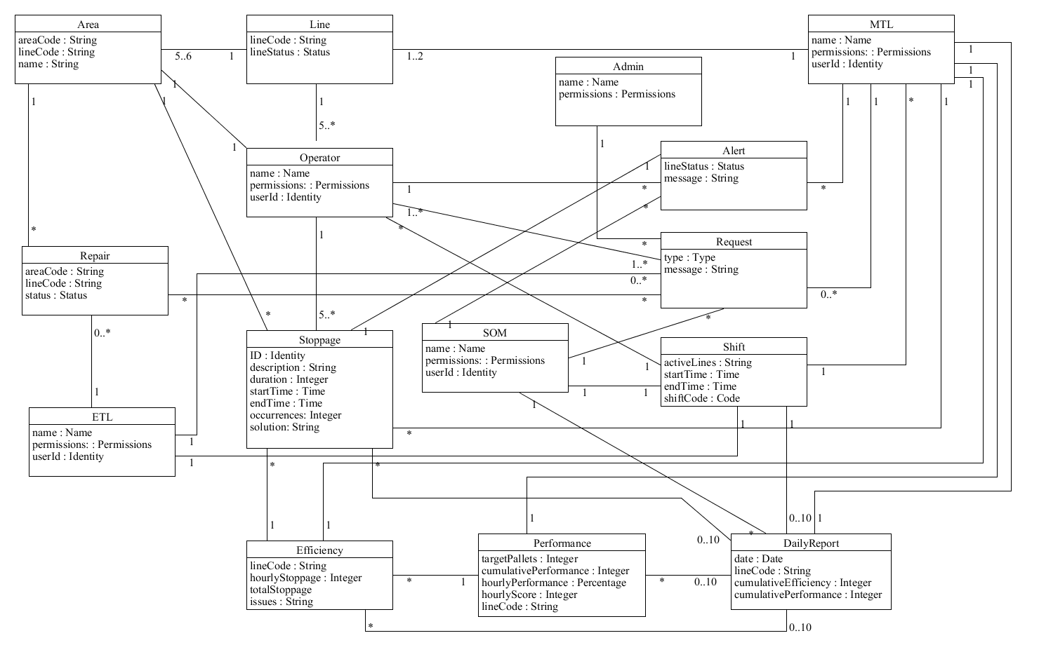

**Figure 1** The conceptual model for downtime management system with attributes and associations.